**Curriculum Vitae**

**PERSONAL DETAILS**

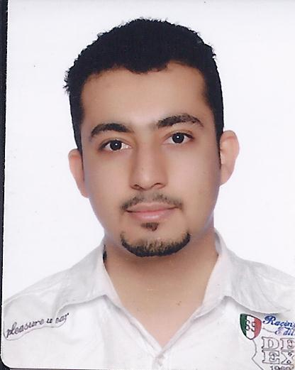

|  |  |
| --- | --- |
| **Name** | **Hussain Jassim Ebrahim Ahmed Yusuf** |
| **Date of Birth** | **20 SEP 1984** |
| **Marital Status** | **Married** |
| **Nationality** | **Bahraini** |
| **Address** | **flat.51, Road No. 2027**  **Building 2232, Complex 1020, AL Lozi** |
| City and State | **Roundabout 7 ,Kingdom of Bahrain** |
| **CPR No.** | **840906188** |
| **Passport No** | **2295659** |
| **Contact No.** | **33231976 __36301012** |
| **E-mail** | [**hh2015Star@hotmail.com**](mailto:hh2015Star@hotmail.com) |

**EDUCATIONAL QUALFICTIONS**

**1999-2002 Secondary School Certificate (Technical in the specialization of Office Appliances)**

**(Sheikh Abdulla secondary school).**

**CERTIFICATES**

|  |  |
| --- | --- |
|  |  |
| **2005** | **Certificate of Achievement - Baisan Institute of Hospitality Management.**Three month |
| **2002** | **Industrial Work Experience Certificate - Rouben's Store in the Specialization**  **of office appliances, one months (Training by Technical secondary Education).** |

**WORKING EXPERIENCES**

|  |
| --- |
| * **I have experience in G4S Security Services (Bahrain) W.L.L one year 2005-2006.** * **Lulu HYPERMARKET in RAMLI Mall _Cashier Two year 2010-2012.** * **I have experience in The Butcher Shop &Grill as Food Runner in City Centre One** * **year2012-2013.** * **I have experience in security guard choueifat school in Amwaj Island one year2015-2016** * **I have experience in Supervisor security in coco beach in Meena7 In the building Amwaj Island.2016_2017.** * **I have experience in SECURTY SOLUTIONS CO. W.L.L.2017-2018.** * **I have experience in SECURTY AL-ENMA'A In Kuwait finance House In bank .**   **LANGUAGE KNOWN** |
| **: MS( Word, PowerPoint, Excel), Typing(Arabic & English).** |
| **: Arabic & English — Well developed communication skills in reading, writing and speaking in both languages.** |

**HOBBIES**

* **Reading stories and information culture and writing.**
* **Using computer and internet.**
* **Basketball and Swimming.**
* **Professional in making fresh juice of all kinds of juice.**
* **Driving a bicycle.**
* **Sports in the gym.**

**OTHER SKILLS**

* **Fully capable of using Internet .**

**ADDITIION INFORMATION**

* **1. fast learning and improve. 2- Ready for training.**